**What is an Integrated Circuit (IC)**

**Normally** [**bipolar junction transistors**](https://www.electrical4u.com/bipolar-junction-transistor-or-bjt-n-p-n-or-p-n-p-transistor/)**,** [**diodes**](https://www.electrical4u.com/diode-working-principle-and-types-of-diode/) **and** [**field effect transistors**](https://www.electrical4u.com/jfet-or-junction-field-effect-transistor/) **are commonly used electronics component in electronic circuit. These components are interconnected along with required** [**resistors**](https://www.electrical4u.com/types-of-resistor/) **and** [**capacitors**](https://www.electrical4u.com/what-is-capacitor/) **to form an electronic circuit. This type of circuit is known as discrete circuit as each of the components can be separated from the circuit as when required. Nowadays there is a new trend of producing electronic circuit where on a** [**semiconductor**](https://www.electrical4u.com/theory-of-semiconductor/) **wafer numbers of diodes,** [**transistors**](https://www.electrical4u.com/jfet-or-junction-field-effect-transistor/)**, and capacitors are permanently fabricated.**

**As the components in this type of electronic circuit are not separable that is integrated on the semiconductor wafer, this circuit is commonly referred to as an Integrated Circuit. IC is also popularly known as chip or microchip.**

## **Types of Integrated Circuits (ICs)**

**There are two main types of integrated circuits: **digital ICs** or **analog ICs**. These types of ICs are discussed in detail below.**

### **Analog IC**

**In this **type of ICs**, the input and output both signals are continuous. The output signal level depends upon the input signal level and the output signal level is a linear function of input signal level. **Linear ICs** or analog ICs are most commonly used as audio frequency amplifier and radio frequency amplifier.** [**Op amps**](https://www.electrical4u.com/op-amp-working-principle-of-op-amp/)**,** [**voltage**](https://www.electrical4u.com/voltage-or-electric-potential-difference/) **regulators, comparators and timers are also well-known examples of **linear ICs** or analog ICs.**

### **Digital IC**

**The** [**logic Gates**](https://www.electrical4u.com/some-common-applications-of-logic-gates/)**, such as** [**AND gate**](https://www.electrical4u.com/logical-and-gate/)**,** [**OR gate**](https://www.electrical4u.com/logical-or-gate/)**,** [**NAND gate**](https://www.electrical4u.com/nand-gate/)**,** [**XOR gate**](https://www.electrical4u.com/exclusive-or-gate/)**,** [**flip flops**](https://www.electrical4u.com/latches-and-flip-flops/)**, counters; microprocessors are some well-known examples of **digital ICs**. These ICs operate with binary data such as either 0 or 1. Normally in digital circuit, 0 indicates 0 V and one indicate +5 V. Digital ICs are commonly used in many electronics projects, and are often available as added components to the** [**top Arduino starter kits**](https://www.electrical4u.com/best-arduino-starter-kit/)**.**

**The main components of an IC are transistors. These transistors may be bipolar or field effect depending upon the applications of ICs.**

**As the technology is improving day by day, the number of transistors incorporated in a single IC chip is also increasing. Depending upon the number of transistors incorporated in a single chip, the ICs are categorized in five groups. Namely,**

|  |  |
| --- | --- |
|  | |
| **i)** | **Small Scale Integration (SSI) where the number of transistors incorporated in a single IC chip is up to 100.** |
| **ii)** | **Medium Scale Integration (MSI) where the number of transistors incorporated in a single IC chip is from 100 to 1000.** |
| **iii)** | **Large Scale Integration (LSI) where the number of transistors incorporated in a single IC chip is from 1000 to 20,000.** |
| **iv)** | **Very Large Scale Integration (VLSI) where the number of transistors incorporated in a single IC chip is from 20,000 to 10,00,000.** |
| **v)** | **Ultra Large Scale Integration (ULSI) where the number of transistors incorporated in a single IC chip is from 10,00,000 to 1,00,00,000.** |

**Depending upon the active devices used in ICs, it can be further classified as bipolar ICs and unipolar ICs. In bipolar ICs the main components are bipolar junction transistors, whereas in unipolar ICs the main components are** [**field effect transistors**](https://www.electrical4u.com/jfet-or-junction-field-effect-transistor/) **or** [**MOSFETs**](https://www.electrical4u.com/mosfet-working-principle-of-p-channel-n-channel-mosfet/)**.**

## **IC Manufacturing Process**

**There are two **types of IC** manufacturing technologies one is monolithic technology and other is hybrid technology. In monolithic technique, all electronic component and their interconnections are manufactured together into a single chip of silicon. This technology is applied when identical ICs to be produced in large scale. Monolithic ICs are cheap but reliable.**

**In hybrid ICs, separate components are attached on a ceramic substance and interconnected by wire or metallization pattern.**

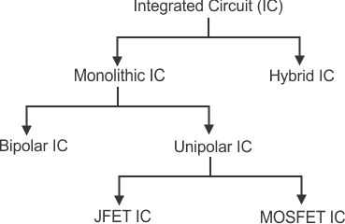

**The advantages of integrated circuits (ICs) include:**

1. **It is quite small in size practically around 20,000 electronic components can be incorporated in a single square inch of IC chip.**
2. **Many complex circuits are fabricated in a single chip and hence this simplifies the designing of a complex electronic circuit. Also it improves the performance.**
3. **Reliability of ICs is high**
4. **These are available at low cost due to bulk production.**
5. **ICs consume very tiny power.**
6. **Higher operating speed due to absence of parasitic capacitance effect.**
7. **Very easily replaceable from the mother circuit.**

**Disadvantages of Integrate Circuit or IC**

**The disadvantages of integrated circuits (ICs) include:**

1. **Because of its small size, IC is unable to dissipate heat in required rate when**[**current**](https://www.electrical4u.com/electric-current-and-theory-of-electricity/)**in it increased. That is why ICs are often damaged due to over current flowing through them.**
2. [**Inductors**](https://www.electrical4u.com/what-is-inductor-and-inductance-theory-of-inductor/)**and**[**Transformers**](https://www.electrical4u.com/what-is-transformer-definition-working-principle-of-transformer/)**cannot be incorporated in ICs**

### **Monolithic IC’s**

**We have already discussed the basics of**[**Integrated Circuits**](https://www.circuitstoday.com/integrated-circuits)**in our previous post. The concepts of a basic monolithic IC will be discussed here.**

**To know the basics a sample circuit must be considered to be converted to its monolithic form. With basic components like resistor, diode, and transistor a basic circuit is first made.**

[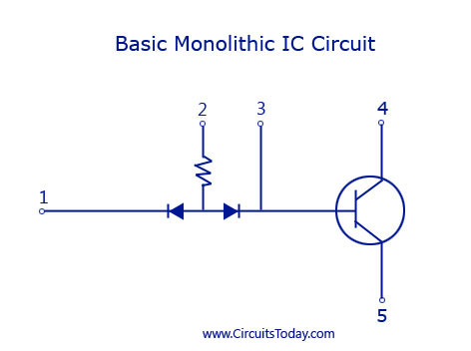](https://www.circuitstoday.com/wp-content/uploads/2009/09/Basic-Monolithic-IC-Circuit.jpg)



**With the basic circuit, the different layers for the monolithic IC are then considered. The basic structure of a monolithic IC will have 4 layers of different materials. The base layer will be a P-type silicon layer and is named as the substrate layer. This layer will have a typical thickness of 200 micrometer. Silicon is the preferred semiconductor for the P-type and N-type layer because of its favourable characteristics for the manufacturing of an IC.**

**The layer above the substrate P-type silicon layer is the N-type layer. All the active and passive components required for the circuit are fabricated onto this layer. This layer has a typical thickness of 25 micrometer. The N-type silicon material is grown as a single crystal extension of the P-layer and the components are required are fabricated using series of P-type and N-type impurity diffusions. The N-type layer becomes the collector for the transistor or an element for a diode or a capacitor.**

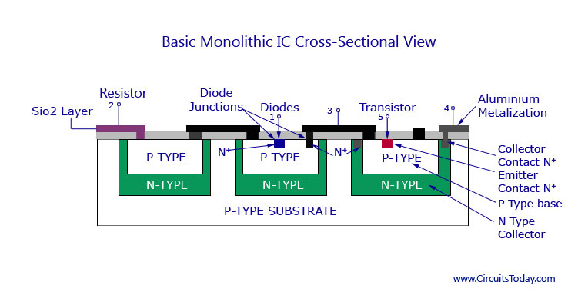

**The layer above N-type is made of silicon dioxide (SiO2) material. Since there is a selective P-type and N-type impurity diffusion going on in the second layer, this layer acts as a barrier in the process. This layer is etched away from the region where diffusion is desired to be permitted with**[**photolithographic process**](https://www.circuitstoday.com/photolithography)**. The rest of the wafer remains protected against diffusion. This layer also protects the silicon layer from contamination.**

**The up-most layer is that made of aluminium. This metallic layer is used to provide interconnections between the different components used in the IC.**

### **Monolithic IC Manufacturing Process**

**For the manufacture and production of the monolithic IC, all circuit components and their interconnections are to be formed in a single thin wafer. The different processes carried out for achieving this are explained below.**

****1. P-layer Substrate Manufacture****

**Being the base layer of the IC, the P-type is silicon is first built for the IC. A silicon crystal of P-type is grown in dimensions of 250mm length and 25mm diameter. The silicon is then cut into thin slices with high precision using a diamond saw. Each wafer will precisely have a thickness of 200 micrometer and a diameter of 25 mm. These thin slices are termed wafers. These wafers may be circular or rectangular in shape with respect to the shape of the IC. After cutting hundreds of them each wafer is polished and cleaned to form a P-type substrate layer.**

****2. N-type Epitaxial Growth****

**The epitaxial groth process of a low resistive N-type over a high resistive P-type is to be carried out. This is done by placing the n-type layer on top of the P-type and heating then inside a diffusion furnace at very high temperature (nearly 1200C). After heating, a gas mixture f Silicon atoms and pentavalent atoms are also passed over the layer. This forms the epitaxial layer on the substrate. All the components required for the circuit are built on top of this layer. The layer is then cooled down, polished and cleaned.**

****3. The Silicon Dioxide Insulation Layer****

**As explained above, this layer is required contamination of the N-layer epitaxy. This layer is only 1 micrometer thin and is grown by exposing the epitaxial layer to oxygen atmosphere at 1000C. A detailed image showing the P-type, N-type epitaxial layer and SiO2 layer is given below.**

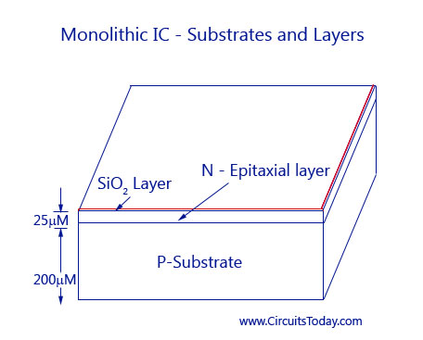

****Photolithographic Process for SiO2****

**To diffuse the impurities with the N-type epitaxial region, the silicon dioxide layer has to be etched in selected areas. Thus openings must be brought at these areas through**[**photolithographic process**](https://www.circuitstoday.com/photolithography)**. In this process, the SiO2 layer is coated with a thin layer of a photosensitive material called photoresist. A large black and white pattern is made in the desired patter, where the black pattern represents the area of opening and white represents the area that is left idle. This pattern is reduced in size and fit to the layer, above the photoresist. The whole layer is then exposed to ultraviolet light. Due to the exposure, the photoresist right below the white pattern becomes polymerized. The pattern is then removed and the wafer is developed using a chemical like trichloroethylene. The chemical dissolves the unpolymerized portion of the photoresist film and leaves the surface.  The oxide not covered by polymerised photoresist is then removed by immersing the chip in an etching solution of HCl. Those portions of the Si02 which are protected by the photoresist remain unaffected by the acid. After the etching and diffusion process, with the help of chemical solvents like sulphuric acid, the resist mask is then removed by mechanical abrasion. The appropriate impurities are then diffused through oxide free windows.**

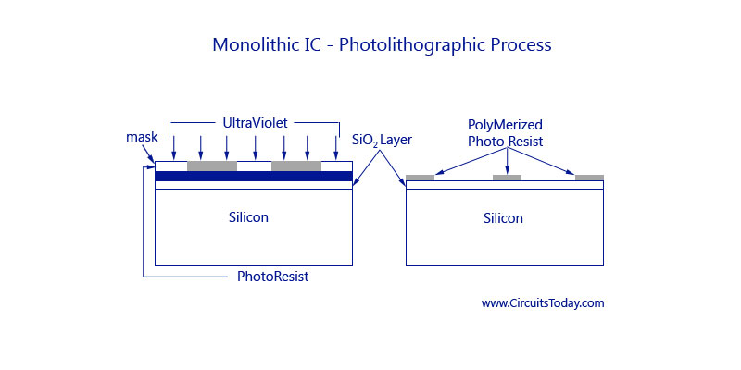

****. Isolation Diffusion****

**After photolithographic process the remaining SiO2 layer serves as a mask for the diffusion of acceptor impurities. To get a proper time period for allowing a P-type impurity to penetrate into the N-type epitaxial layer, isolation diffusion is to be carried out. By this process, the P-type impurity will travel through the openings in SiO2 layer, and the N-type layer and thus reach the P-type substrate, Isolation junctions are used to isolate between various components of the IC. The temperature and time period of isolation diffusion should be carefully monitored and controlled. As a result of isolation diffusion, the formation of N-type region called Isolation Island occurs. Each isolated island is then chosen to grow each electrical component. From the figure below you can see that the isolation islands look like back-to-back P-N junctions. The main use if this is to allow electrical isolation between the different components inside the IC. Each electrical element is later on formed in a separate isolation island. The bottom of the N-type isolation island ultimately forms the collector of an N-P-N transistor. The P-type substrate is always kept negative with respect to the isolation islands and provided with reverse bias at P-N junctions. The isolation will disappear if the P-N junctions are forward biased.**

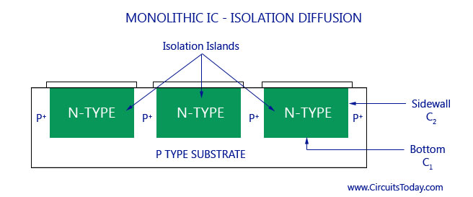

**An effect of capacitance is produced in the region where the two adjoining isolation islands are connected to the P-type substrate. This is basically a parasitic capacitance that will affect the performance of the IC. This kind of capacitance is divided into two.  As shown in the figure C1 is one kind of capacitance that forms from the bottom of the N-type region to the substrate and capacitance C2 from the sidewalls of the isolation islands to the P-region. The bottom component C1 is essentially due to step junction formed by epitaxial growth and, therefore, varies as the square root of the voltage V between the isolation region and substrate. The sidewall capacitance C2 is associated with a diffused graded junction and so varies as (-1/2) exponential of V. The total capacitance is of the order of a few picoFarads.**

****6. Base Diffusion****

**The working of base diffusion process is shown in the figure below. This process is done to create a new layer of SiO2 over the wafer. P-regions are formed under regulated environments by diffusing P-type impurities like boron. This forms the base region of an N-P-N transistor or as well as resis­tors, the anode of diode, and junction capacitor. In this case, the diffusion time is so controlled that the P-type impurities do not reach the substrate. The resistivity of the base layer is usually much higher than that of the isolation regions.**

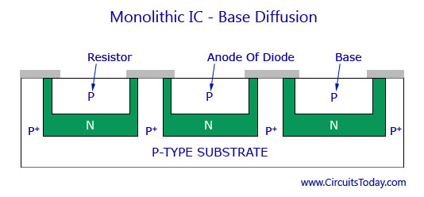

**The isolation regions will have a lot lesser resistivity than that of the base layer.**

**7. Emitter Diffusion**

**Masking and etching process is again carried out to form a layer of silicon dioxide over the entire surface and opening of the P-type region. The transistor emitters, the cathode regions for diodes, and junction capacitors are grown by diffusion using N-type impurities like phosphorus through the windows created through the process under controlled environmental process. As shown in the figure below there are two additional windows: W1 and W2. These windows are made in the N-region to carry an aluminium metallization process.**

[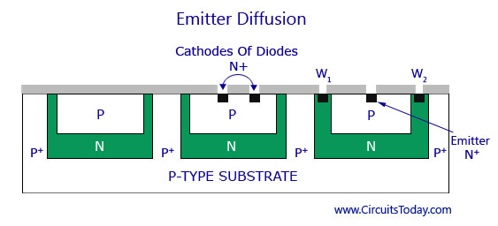](https://www.circuitstoday.com/wp-content/uploads/2009/09/Emitter-Diffusion1.jpg)

****8. Aluminium Metallization****

**The windows made in the N-region after creating a silicon dioxide layer are then deposited with aluminium on the top surface. The same photoresist technique that was used in photolithographic process is also used here to etch away the unwanted aluminium areas. The structure then provides the connected strips to which the leads are attached. The process can be better understood by going through the figure below.**

[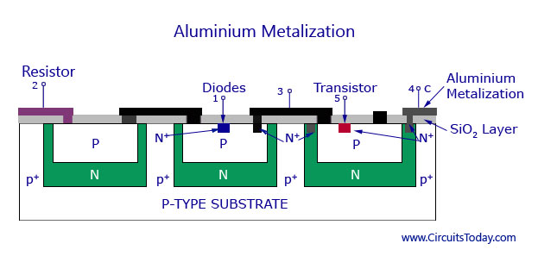](https://www.circuitstoday.com/wp-content/uploads/2009/09/Aluminium-Metalization.jpg)**Aluminium Metalization**

****9. Scribing and Mounting****

**This is the final stage of the IC manufacturing process. After the metallization process, the silicon wafer is then scribed with a diamond tipped tool and separated into individual chips. Each chip is then mounted on a ceramic wafer and is attached to a suitable header. Next the package leads are connected to the IC chip by bonding of aluminium or gold wire from the terminal pad on the IC chip to the package lead. Thus the manufacturing process is complete. Thu, hundreds of IC’s is manufactured simultaneously on a single silicon wafer.**

### **Monolithic IC – Component Fabrication**

**Now we shall discuss in detail how different circuit elements like capacitors, transistors, diodes, and resistors are fabricated into an IC. Please note that it is practically impossible to fabricate an inductor into an IC. It is thus added externally by connecting it to the corresponding IC pin as designed by the manufacturer.**

**Transistors**

**The fabrication process of a transistor is shown in the figure below. A P-type substrate is first grown and then the collector, emitter, and base regions are diffused on top of it as shown in the figure. The surface terminals for these regions are also provided for connection.**

[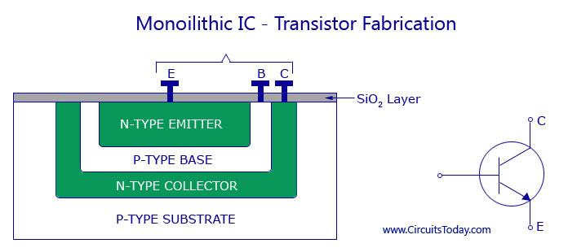](https://www.circuitstoday.com/wp-content/uploads/2009/09/Monoilithic-IC-Transistor-Fabrication.jpg)

**Monoilithic IC - Transistor Fabrication**

**Both transistors and diodes are fabricated by using the epitaxial planar diffusion process that is explained earlier. In case of discrete transistors, the P-type substrate is considered as the collector. `But this is not possible in monolithic IC’s, as all the transistors connected on one P-type substrate would have their collectors connected together. This is why separate collector regions are diffused into the substrate.**

**Even though separate collector regions are formed, they are not completely isolated from the substrate. For proper functioning of the circuit it is necessary that the P-type substrate is always kept negative with respect to the transistor collector. This is achieved by connecting the substrate to the most negative terminal of the circuit supply. The unwanted or parasitic junctions, even when reverse-biased, can still affect the circuit performance adversely. The junction reverse leakage current can cause a serious problem in circuits operating at very low current levels. The capacitance of the reverse-biased junction may affect the circuit high-frequency performance, and the junction break down voltage imposes limits on the usable level of supply voltage. All these adverse effects can be reduced to the minimum if highly resistive material is employed for the substrate. If the substrate is very lightly doped, it will behave almost as an insulator.**

**Diodes**

**They are also fabricated by the same diffusion process as transistors are. The only difference is that only two of the regions are used to form one P-N junction. In figure, collector-base junction of the transistor is used as a diode. Anode of the diode is formed during the base diffusion of the transistor and the collector region of the transistor becomes the cathode of the diode. For high speed switching emitter base junction is used as a diode.**

[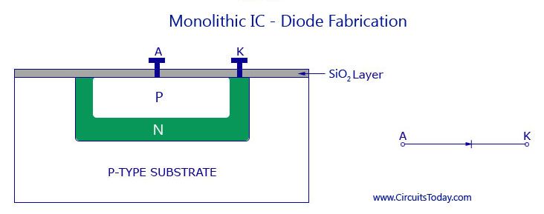](https://www.circuitstoday.com/wp-content/uploads/2009/09/Monolithic-IC-Diode-Fabrication.jpg)**Monolithic IC - Diode Fabrication**

**Resistors**

**The resistors used in IC’s are given their respective ohmic value by varying the concentration of doping impurity and depth of diffusion. The range of resistor values that may be produced by the diffusion process varies from ohms to hundreds of kilohms. The typical tolerance, however, may be no better than ± 5%, and may even be as high as ± 20%. On the other hand, if all the resistors are diffused at the same time, then the tolerance ratio may be good. Most resistors are formed during the base diffusion of the integrated transistor, as shown in figure below. This is because it is the highest resistivity region. For low resistance values, emitter region is used as it has much lower resistivity.**

**Another diffusion technique is also used for the growth of IC resistors. It is basically a thin-film technique. In this process a metal film is deposited on a glass or Si02 surface. The resistance value can be controlled by varying thickness, width and length of the film. Since diffused resistors can be processed while diffusing transistors. This technique is more economic and less time consuming and therefore, the most widely used.**

**Capacitors**

**The figure below shows the P and N-regions forming the capacitor plates. The dielectric of the capacitor is the depletion region between them.**

[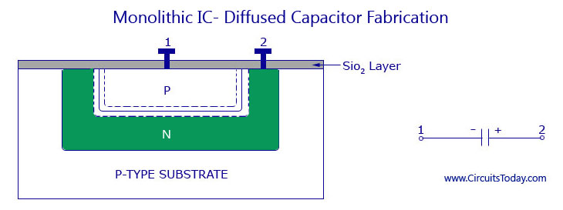](https://www.circuitstoday.com/wp-content/uploads/2009/09/Monolithic-IC-Diffused-Capacitor-Fabrication.jpg)**Monolithic IC - Diffused Capacitor Fabrication**

**All P-N junctions have capacitance so capacitors may be produced by fabricating junctions. The amount of change in the reverse bias varies the value of junction capacitance and also the depletion width. The value may be as less as 100 picoFarads.**

[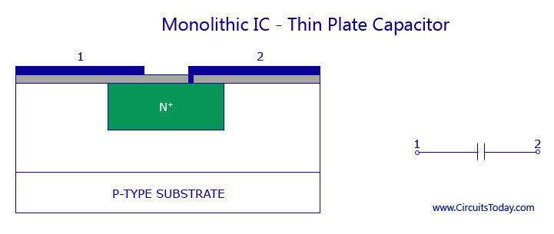](https://www.circuitstoday.com/wp-content/uploads/2009/09/Monolithic-IC-Thin-Plate-Capacitor.jpg)**Monolithic IC - Thin Plate Capacitor**

**Using the silicon dioxide as a dielectric may also be a way to fabricate capacitors. One plate of the capacitors is formed by diffusing a heavily doped N-region. The other plate of the capacitor is formed by depositing a film of aluminium on the silicon dioxide dielectric on the wafer surface. For such a capacitor, a voltage of any polarity can be used, and when comparing a diffused capacitor with such a capacitor the diffused capacitor may have very small values of breakdown voltage.**

## **Integrated Circuits (IC’s)**

**The concept of IC was first introduced in the year 1958. Since then this concept has reached great technological heights than any other concepts and has helped in the miniaturization of a lot of components like mobiles, computers, laptops, and many more devices in the digital world.**

**The digital era started with the invention of vacuum tubes. Vacuum based computers were rare and expensive. This was then replaced by transistors, which were faster in use and smaller in size, cost effective, less power consuming and reliable.  Then came the invention of integrated circuits which just revolutionized the use of computers. Due to its small dimension, low cost, and very high reliability even the common man is familiar with its applications like smart phones and laptops.**

**The IC’s also found its way in military applications, state of the art communication systems, and industrial applications due to its high reliability and compact size. Nowadays, an IC that has the size of a fingernail consists of more than a million transistors and other discrete components embedded into it. Thus an integrated circuit can also be called a microchip and is basically a collection of some discrete circuits on a small chip that is made of a semiconductor material like silicon.**

**The use of discrete circuits was replaced by IC’s due to two factors. One is space consumption. A discrete circuitry consists of transistors, resistors, diodes, capacitors, and many other discrete devices. Each of them is soldered on to printed circuit boards (PCB) according to the need of circuitry. In the end PCB will occupy a large space. Another drawback is that the soldered components will show less reliability due to the use of many components. Both these factors urged engineers to invent microcircuits that have more reliability and consume less space.**

**The idea of an integrated circuit was first proposed by Geoffrey W. A. Dummer in the year 1952. But the attempt to build it led to failure. Another idea was proposed by Jack Kilby. He came up with an idea to create small ceramic wafers where each wafer carried a small miniature discrete component. All these wafers could then be wired to form a compact circuit. But this concept, though developed for the U.S army failed to find momentum and was discarded.  
Shortly soon, the very same Jack Kilby came up with the original idea of making an IC while he was working for Texas Instruments. He started building his first IC and finally completed it on 12th September 1958. He made his IC using germanium as the semiconductor chip. This invention won him the Nobel prize for physics in the year 2000. Soon Robert Noyce developed his own prototype of an IC, using silicon as a semiconductor material. This invention helped in resolving many practical problems that Jack Kilby’s IC had.**

**All IC’s consist of both active and passive components and the connections between them are so small that it may be impossible to see them even though a microscope. All the components (active and passive) are interconnected through fabrication process.**

**In a circuit diagram, there is no common symbol for representing an IC. They are mostly available as dual in-line packages, metal cans and also ceramic flat packs. They may be 8-pin, 10-pin, or 14-pin depending on the specification of the manufacturer.**

## **Merits and Demerits**

### **Advantages of Integrated Circuits**

**1. Miniature in size. As fabrication process is used for the integration of active and passive components on to a silicon chip, the IC becomes a lot smaller. When compared to a  discrete circuit, it may be at least a thousand times smaller.**

**2. Due to small size, the weight of the IC also reduces, when compared to the discrete circuit.**

**3. To produce hundreds of discrete circuits on a PCB for  the same logic takes more time and increase the cost factor. But for the production of hundreds of IC’s the cost of production will be very low and less time consuming.**

**4. The PCB consisting soldered joints will be less reliable. This problem is omitted in IC’s because of no soldered joints, with fewer interconnections, and thus highly reliable.**

**5. The small size of IC’s causes lesser power consumption and lesser power loss.**

**6. In a discrete circuitry, if a single transistor becomes faulty, the whole circuit may fail to work. This transistor has to be desoldered and replaced. It is difficult to find out which component has failed. This problem can be omitted in an IC by replacing an entire IC as it is low in cost.**

**7. Increased operating speed because of absence of parasitic capacitance effect.**

**8. As the IC’s are produced in bulk the temperature coefficients and other parameters will be closely matching.**

**9. Improved functional performance as more complex circuits can be fabricated for achieving better characteristics.**

**10. All IC’s are tested for operating ranges in very low and very high temperatures.**

**11. As all the components are fabricated very close to each other in an IC, they are highly suitable for small signal operation, as there won’t be any stray electrical pickup.**

**12. As all the components are fabricated inside the chip, there will not be any external projections.**

### **Disadvantages of Integrated Circuits**

**1. Some complex IC’s maybe costly. If such integrated circuits are used roughly and become faulty, they have to be replaced by a new one. They cannot be repaired as the individual components inside the IC are too small.**

**2. The power rating for most of the IC’s does not exceed more than 10 watts. Thus it is not possible to manufacture high power IC’s.**

**3. Some components like transformers and inductors cannot be integrated into an IC. They have to be connected externally to the semiconductor pins.**

**4. High grade P-N-P assembly is not possible.**

**5. The IC will not work properly if wrongly handled or exposed to excessive heat.**

**6. It is difficult to achieve low temperature coefficient.**

**7. It is difficult to fabricate an IC with low noise.**

**8. It is not possible to fabricate capacitors that exceed a value of 30pF. Thus, high value capacitors are to be connected externally to the IC.**

**9.  There is a large value of saturation resistance of transistors.**

## **Integrated Circuit – Classification**

**All the IC’s have interconnected discreet devices inside the chip and the corresponding external connecting terminals outside. Each pin may have each function and may vary according to the manufacturer’s design. In order to make the circuit fully operative, the pins in the IC must be used for supply voltage, input and output connections, and also some external components according to the needs of the manufacturer.**

**ICs can be classified on the basis of their chip size as given below:**

****Small scale integration (SSI)—3 to 30 gates/chip.****

****Medium scale integration (MSI)—30 to 300 gates/chip.****

****Large scale integration (LSI)—300 to 3,000 gates/chip.****

****Very large scale integration (VLSI)—more than 3,000 gates/chip.****

### **IC Types**

[[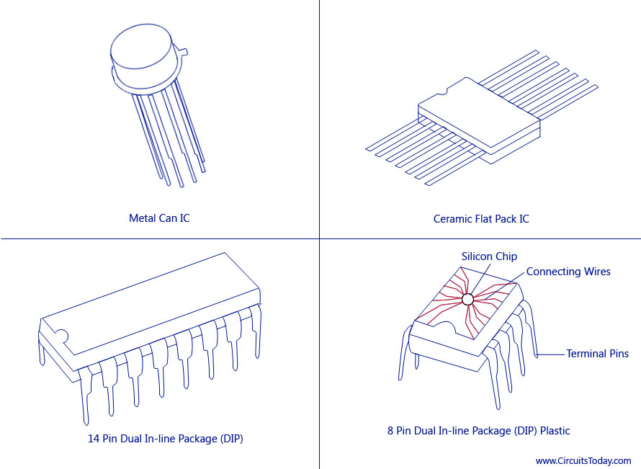](http://www.circuitstoday.com/wp-content/uploads/2009/09/IC-Types.jpg)](http://www.circuitstoday.com/wp-content/uploads/2009/09/IC-Types.jpg)

**IC Types**

**On the basis of applications ICs are of two types namely: Linear Integrated Circuits and Digital Integrated Circuits.**

**Linear IC’s are used in cases when the relationship between the input and output of a circuit is linear. An important application of linear IC is the operational amplifier commonly referred to as op-amp.**

**When the circuit is either in on-state or off-state and not in between the two, the circuit is called a digital circuit. IC’s used in such circuits are called digital IC’s. They find wide applications in computers and logic circuits.**

**Here are some further classification of integrated circuits based on the fabrication techniques used.**

****1. Monolithic Integrated Circuits****

**The word ‘monolithic’ comes from the Greek words ‘monos’ and ‘lithos’ which means ‘single’ and ’stone’. As the name suggests, monolithic IC’s refer to a single stone or a single crystal. The single crystal refers to a single chip of silicon as the semiconductor material, on top of which all the active and passive components needed are interconnected. This is the best mode of manufacturing IC’ as they can be made identical, and produces high reliability. The cost factor is also low and can be manufactured in bulk in very less time. They have been found applicable for C’s used for AM receivers, TV circuits, computer circuits, voltage regulators, amplifiers and so on.**

**A detailed article explaining the concept and fabrication process of different components and monolithic IC production process is explained here –**[**Monolithic Integrated Circuit**](http://www.circuitstoday.com/monolithic-ic)**.**

[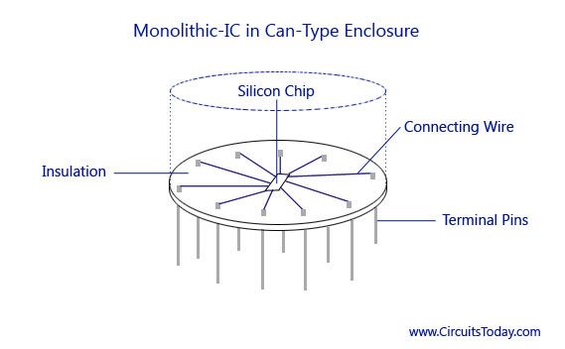](http://www.circuitstoday.com/wp-content/uploads/2009/09/Monolithic-IC-Can-Type.jpg)

**Monolithic IC – Can Type**

**Being as it is, monolithic IC’s have some limitations as well.**

**1. Monolithic IC’s have low power rating. They cannot be used for low power applications as they cannot have a power rating of more than 1 watt.**

**2. The isolation between the components inside the IC is poor.**

**3. Components like inductor cannot be fabricated to the IC.**

**4. The passive components that are fabricated inside the IC will be if small value. For higher values they have to be connected externally to the IC pins.**

**5. It is difficult to make a circuit flexible for any kind of variation; a new set of masks is required.**

### **2. Thin and Thick Film Integrated Circuit**

**Thick and thin film IC’s are comparatively larger than monolithic IC’s and smaller than discrete circuits. They find their use in high power applications. Though it is a little large in size, these IC’s cannot be integrated with transistors and diodes. Such devices have to be externally connected on to its corresponding pins. Passive components like resisters and capacitors can be integrated.**

**Both thick and thin film IC’s are explained in detailed below. Though both the IC’s have similar appearance, properties, and general characteristics, the main difference between the two of them is the manner in which the film is deposited on to the IC.**

****Thin Film Integrated Circuits****

**This IC is fabricated by depositing films of conducting material on the surface of a glass or ceramic base. The resistors are fabricated by controlling the width and thickness of the films and by using different materials selected for their resistivity. For capacitors, a film of insulating oxide is sandwiched between two conducting films. A spiral form of film is deposited onto the IC to create an inductor.**

**Mainly two methods are used for producing thin films. One method, called vacuum evaporation is used in which vaporized material is deposited on a substrate contained in a vacuum. The other method is called cathode sputtering in which atoms from a cathode made of the desired film material are deposited on a substrate located between a cathode and an anode.**

****Thick Film Integrated Circuits****

**They are also commonly called as printed thin film circuits. The desired circuit pattern is obtained on a ceramic substance by using a manufacturing process called silk-screen printing technique.**

**The inks used for printing are usually materials that have resistive, conductive, or dielectric properties. They are selected accordingly by the manufacturer. The screens are actually made of fine stainless steel wire mesh. The films are fused to the substrate after printing by placing them in hot high temperature furnaces.**

**The fabrication techniques used for thin film passive components are adopted for thick films as well. As with thin-film circuits, active components are added as separate devices. A portion of thick-film circuit is given in the figure below.**

[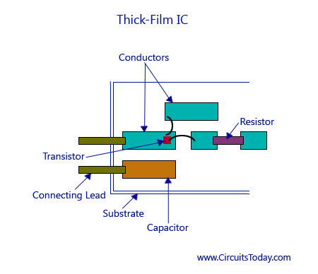](http://www.circuitstoday.com/wp-content/uploads/2009/09/Thick-Film-IC.jpg)

**Thick Film IC**

**When compared to monolithic IC’s, thick and thin film IC’s do have some advantages. They have the advantage of better tolerance, better isolation between components, and greater flexibility in circuit design that further helps in providing high frequency performance. But, these are the only factors that must be considered for the application of such IC’s as they are costly in making, and has higher dimensions than monolithic IC’s. They also cannot be used to fabricate active components which further increase the size.**

### **3. Hybrid or Multi-chip Integrated Circuits**

**As the name suggests, the circuit is fabricated by interconnecting a number of individual chips. Hybrids ICs are mostly used for high power audio amplifier applications from 5 Watts to more than 50 Watts. The active components are diffused transistors or diodes. The passive components may be group of diffused resistors or capacitors on a single chip, or they may be thin-film components. Interconnection between the individual chips is made by wiring process or a metallized pattern.**

[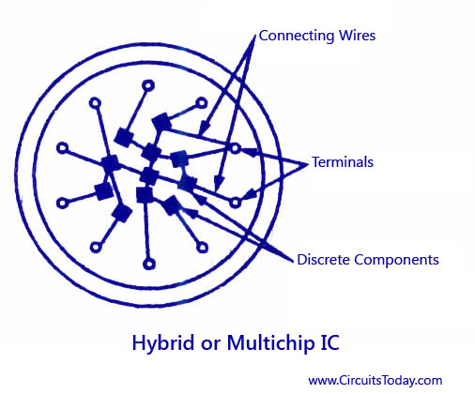](http://www.circuitstoday.com/wp-content/uploads/2009/09/Hybrid-or-Multichip-IC.jpg)**Hybrid IC**

**The diagram of a hybrid or multi-chip IC is shown in the figure above. Hybrid IC’s are also known to provide a better performance than monolithic IC’s. Although the process is too expensive for mass production, multi-chip techniques are quite economical for small quantity production and are more often used as prototypes for monolithic ICs.**

**Based upon the active devices employed the ICs can be classified as bipolar ICs using bipolar active devices (BJT) and unipolar IC’s using unipolar active devices like FET.**